# How to Configure New Relic Monitoring Tool in Centos7/ RHEL7

Create a AWS RHEL7/Centos7 Instance and login to the server and do the below

##### **Step-1:** (Sign up for New Relic Free Account)

You can Sign up for New Relic Free Account

##### **Step-2:** (After Sign up Login to your root account)

[ec2-user@ip-172-31-36-241 ~]$ su -

Password:

##### **Step-3:** (Enable the New Relic Repository)

[root@ip-172-31-36-241 ~]# rpm -ivh https://download.newrelic.com/pub/newrelic/el5/i386/newrelic-repo-5-3.noarch.rpm

##### **Step-4:** (Install the New Relic Packages)

[root@ip-172-31-36-241 ~]# yum install newrelic-sysmond

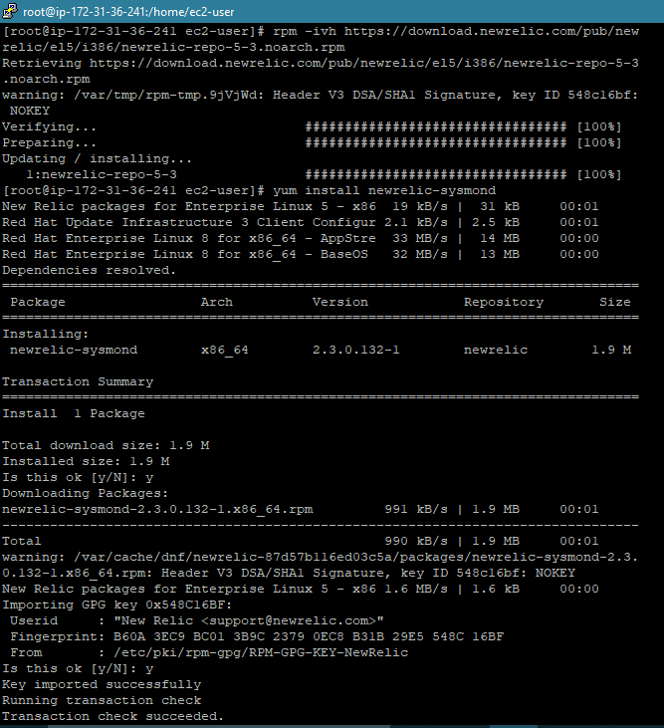

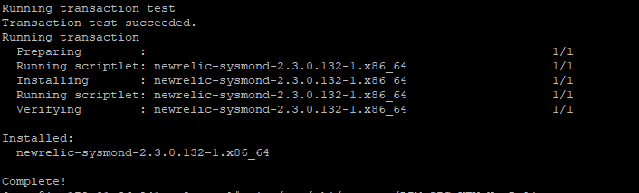

##### **Step-5:** (How to get and find your free license key)

<https://rpm.newrelic.com/accounts/2570610/servers>

Go to the above link or just give servers at the last in the above in your URL account

You can see the below screen and you can select your platform to configure New Relic Agent

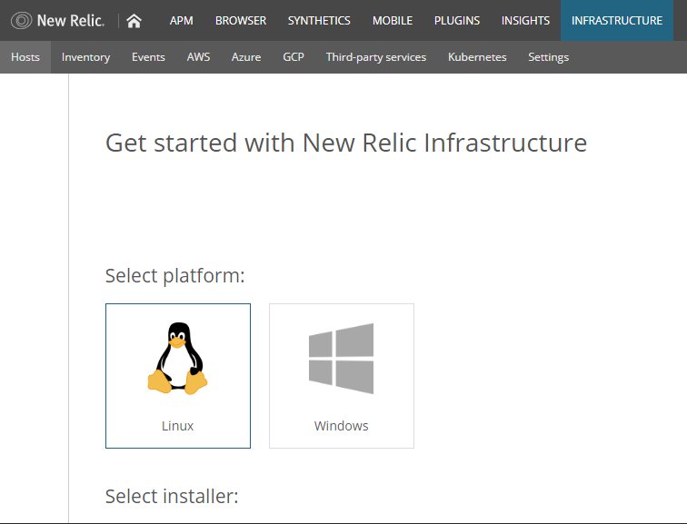

## **Step-6:** Create a configuration file and add your license key

echo "license_key: 44ddb6fe60247c971c95b66a8ba6cbda280fNRAL" | sudo tee -a /etc/newrelic-infra.yml

You can add extra configurations that fine-tune your agent’s behavior and collect custom attributes.



## **Step-7:** Create the agent’s yum repository

**Amazon Linux, CentOS 6, RHEL 6**

sudo curl -o /etc/yum.repos.d/newrelic-infra.repo https://download.newrelic.com/infrastructure_agent/linux/yum/el/6/x86_64/newrelic-infra.repo

**Amazon Linux 2, CentOS 7, RHEL 7**

sudo curl -o /etc/yum.repos.d/newrelic-infra.repo https://download.newrelic.com/infrastructure_agent/linux/yum/el/7/x86_64/newrelic-infra.repo

**CentOS 8, RHEL 8**

sudo curl -o /etc/yum.repos.d/newrelic-infra.repo <https://download.newrelic.com/infrastructure_agent/linux/yum/el/8/x86_64/newrelic-infra.repo>

O/P:



## **Step-8:** Update your yum cache

sudo yum -q makecache -y --disablerepo='*' --enablerepo='newrelic-infra'

O/P:

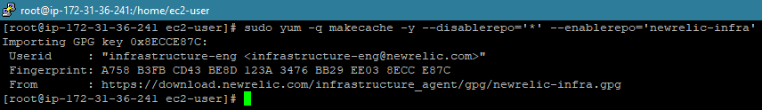

## **Step-9:** Run the installation script

sudo yum install newrelic-infra –y

**Note:** The Service name for new-relic is “**newrelic-infra.service**”

## **Step-10:** Get started

Wait a few seconds, and your data should begin appearing!

You can integrate with your **Amazon Elastic Compute Cloud** (Amazon EC2) account for dynamic-tagging and autoscaling properties

Now, you can able to see the Dashboard containing data as shown below

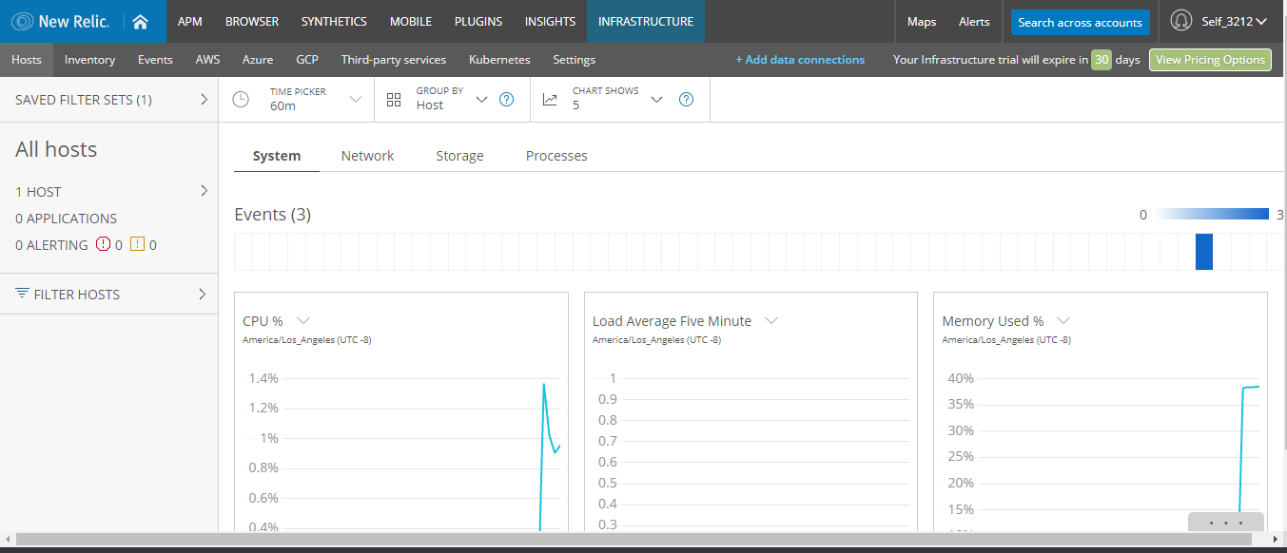

**How To Install the Apache Web Server on CentOS 7**

1. sudo yum install httpd
2. sudo systemctl enable httpd
3. sudo systemctl start httpd
4. sudo mkdir -p /var/www/newrelic/
5. sudo chcon -R --reference=/var/www/html/ /var/www/newrelic/
6. ls -ldZ /var/www/newrelic/

O/p:

drwxr-xr-x. 2 root root system_u:object_r:httpd_sys_content_t:s0 6 Dec 16 06:20 /var/www/mydomain/

1. sudo vi /etc/httpd/conf/httpd.conf

<virtualhost *:80>

servername 35.154.237.77

documentroot /var/www/newrelic

</virtualhost>

1. sudo vi /var/www/mydomain/index.html

<h1> Welcome </h1>

<h2> This is Bharat Kumar Kanuru </h2>

<h3> You are now Seeing Sample Web Page Testing for New Relic Monitoring Tool

</h3>

1. sudo systemctl restart httpd.service

Check the URL

http://< IP_Address_Of_Your_AWS_Instance >

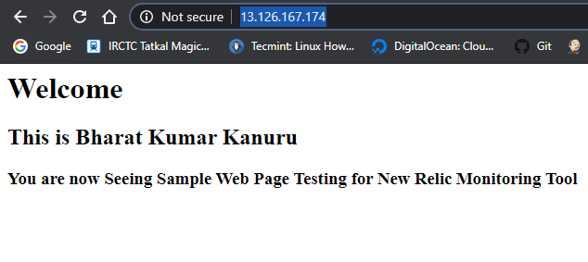

Now go to New Relic Monitoring Monitors Page

<https://synthetics.newrelic.com/accounts/2570610/monitors>

1. Go to SYNTHETICS tab and click on Create New Monitor as shown below

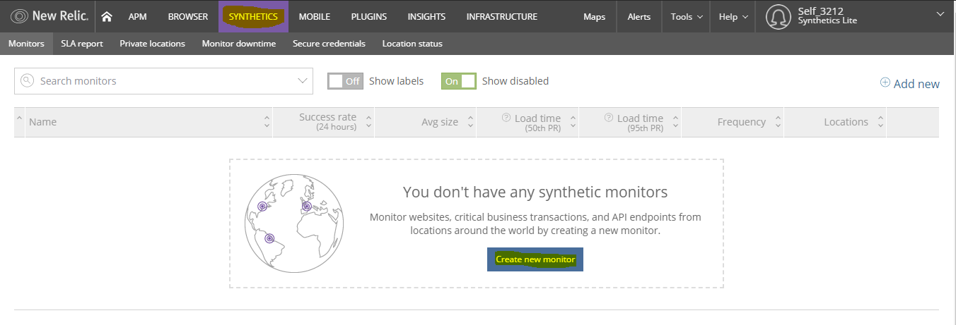

1. Now Choose your Monitor Type (Ping, Simple Browser, Scripted Browser, API Test)
2. Enter the URL Details and Name your Monitor

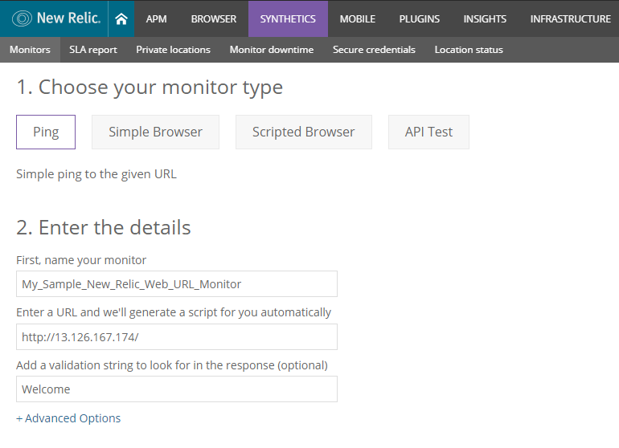

1. Select the Monitoring Locations (If Required)

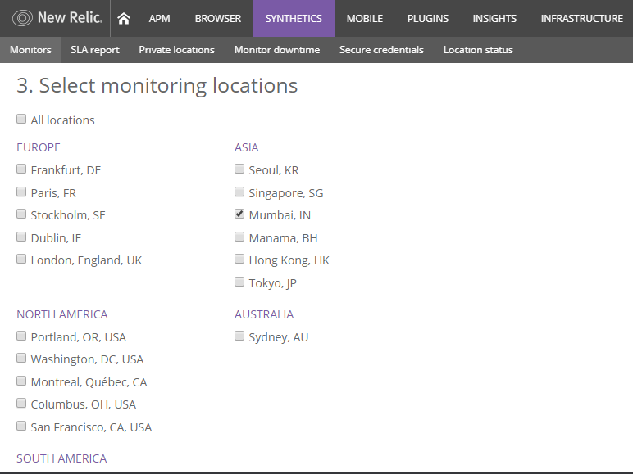

1. Select the Schedule to check the URL for the given locations on a frequency of 1min will run one check for every 1min apart.

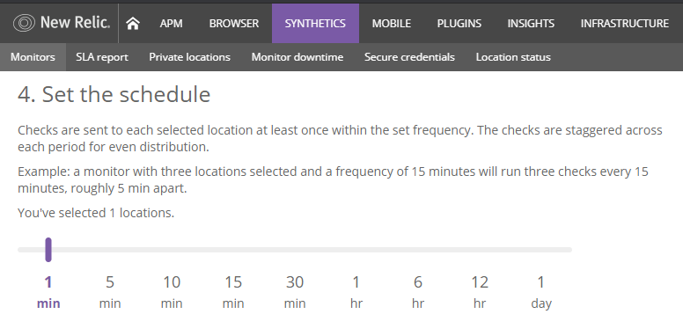

1. Finally, Create Notification by providing email address and Policy and click on Create my Monitor to start the Web URL Monitoring

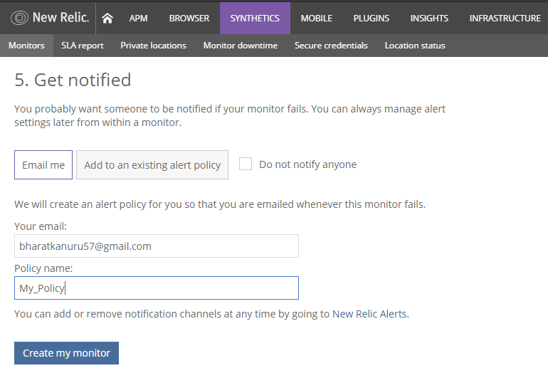

See below the alert stats

Now you can able to see the below Stats for the created alert,

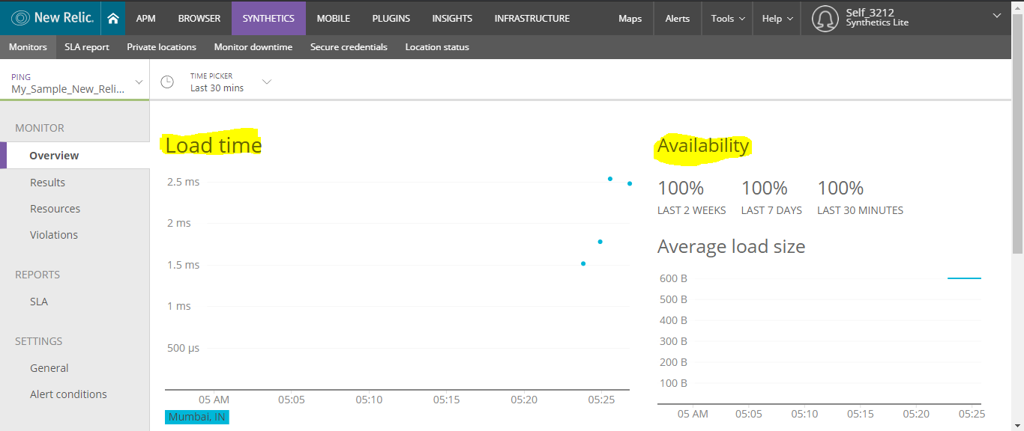

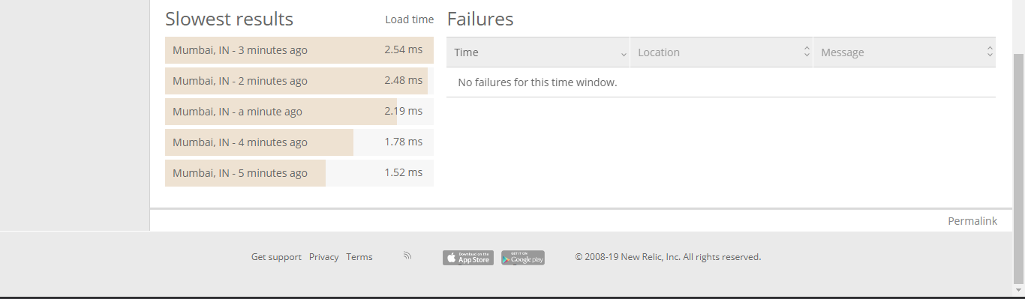

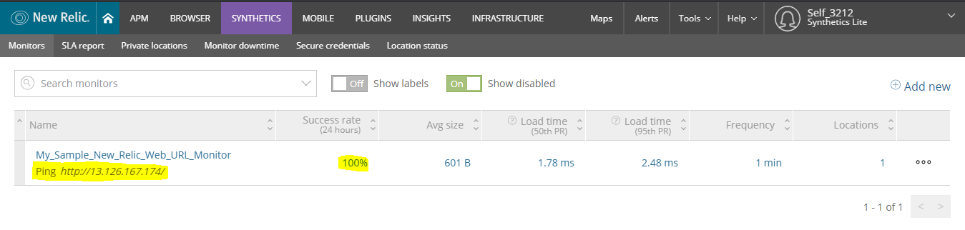

You will be getting Mail Alerts and Failure alerts as shown below.

Monitor Dashboard Alert:

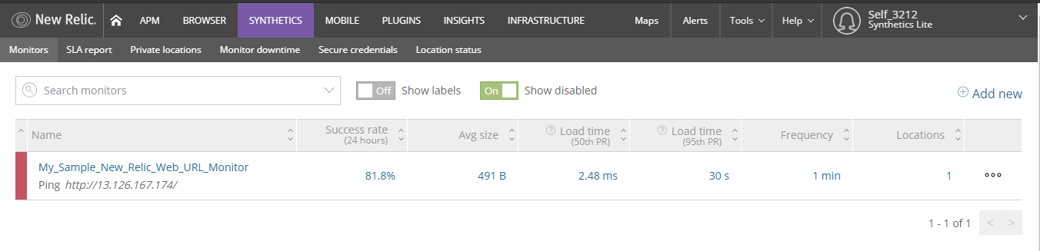

E-mail Alert:

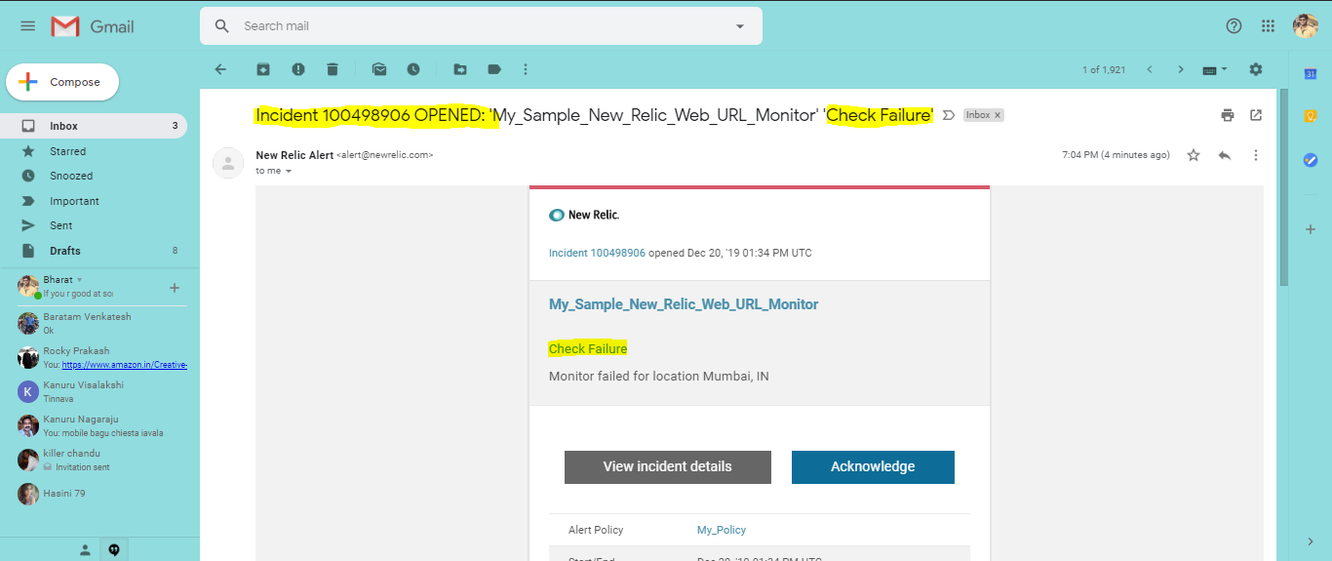

Click on Acknowledge you can be redirected the following page

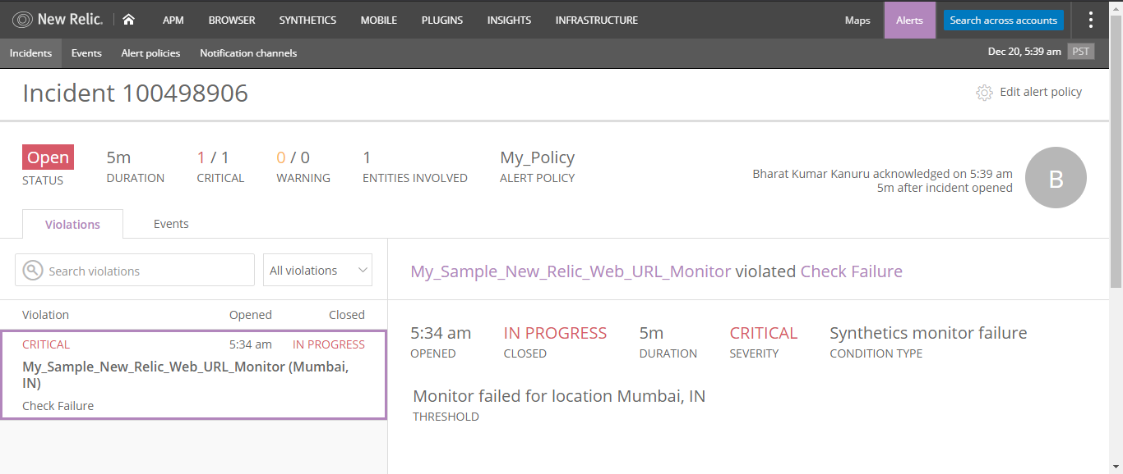

Once you acknowledge the alert you will get an another email as shown below

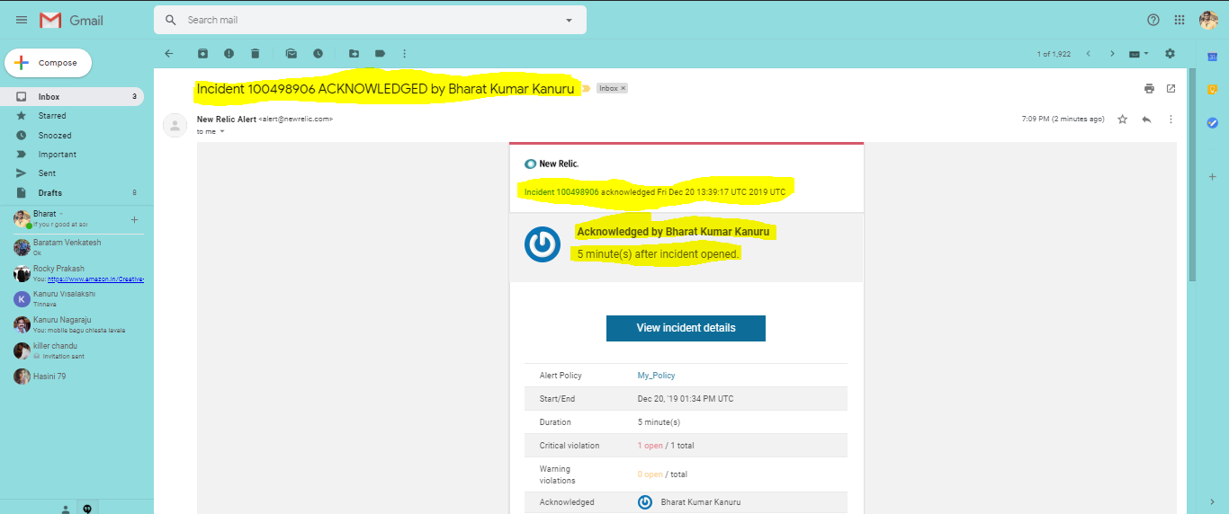

Once the URL is UP we will get recovery email to our mail ID which you have configure as shown below

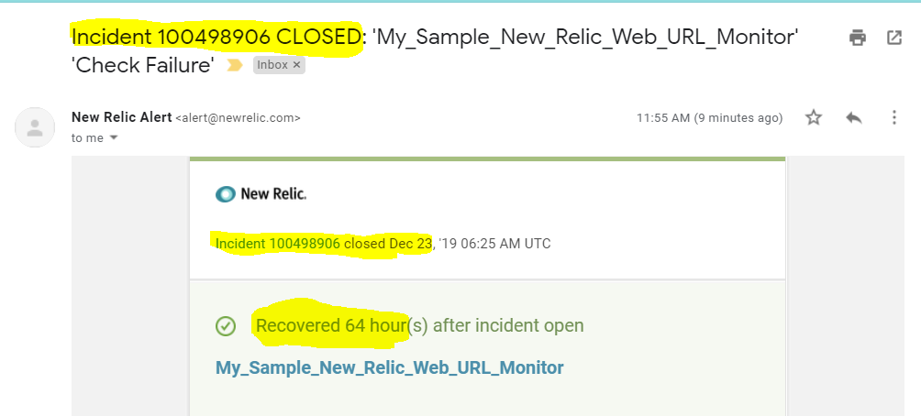

## Thank You

## Kanuru Bharat Kumar